New Taipei Municipal Jinhe High School and California State University, Long Beach

City Walking Tour Route Explanation — Dadaocheng
Date: July 2nd, 2026
1.5 to 2 Hours Dadaocheng Walking Tour Route Description:
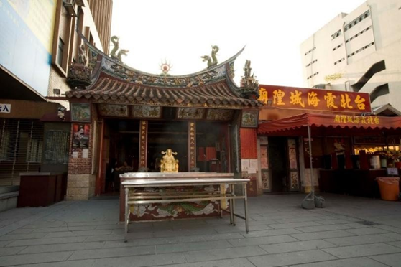
The design of this walking tour route specifically presents a "circular line" that extends from south to north, and then loops back to the core of Dihua Street. Along the way, we will catch a glimpse of modern Taipei's history through the following five points:
- Religious beliefs
- Foreign firm trade
- Modern Taiwanese music
- The rise of the Koo family
- Contemporary life of the common people

Stop 1: Taipei Xia-Hai City God Temple
- Historical Insight:
Established in 1859, this temple serves as a symbol of the immigrants reuniting after the "Ting-Hsia Jiao-Ping" (a mid-19th-century clan conflict in Taipei). In addition to the patron deity, the City God, it is most famous for the Matchmaker (God of Love). This allows both Taiwanese and international students to observe how devotees worship and experience Taiwan's unique "temple culture shock."
- Route Guide:
Starting from the City God Temple, head west through the alleys next to Minsheng West Road and enter the historically famous "Foreign Firm Street" — Guide Street.

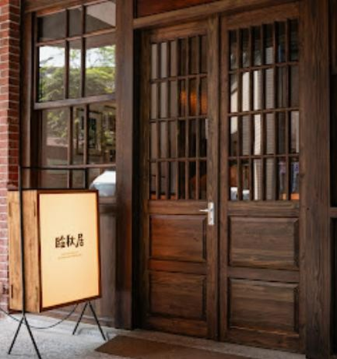
Stop 2: Former Residence of Li Lin-chiu
Walk into the alley to reach the creative base of this master of modern Taiwanese ballads.
- Historical Insight:
Li Lin-chiu is a highly representative Taiwanese lyricist. The Taiwanese ballad "Bang Chhun Hong" (Yearning for the Spring Breeze), which is familiar throughout the Chinese-speaking world, is his work. Here, the tour guide can introduce international students to the historical background of the 1930s when Dadaocheng served as the cradle of Taiwan's pop music and the New Culture Movement.
- Route Guide: Continue walking north along Guide Street for about 1 minute.

Stop 3: Chuang Hsieh-fa Shop (Qianqiu Street Shop-house)
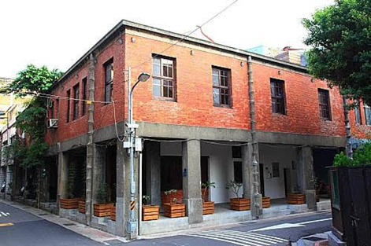
Observe the historical shop-houses that remain from Dadaocheng's earliest European-style blocks dating back to the Qing Dynasty.
- English Guide & Historical Insight:
In the late Qing Dynasty, Guide Street was known as "Qianqiu Street" and "Jianchang Street," and it was the first Western-style street in Taiwan. The Chuang Hsieh-fa Shop is a typical Qing Dynasty historic shop-house that was originally used as a grocery store. Its architecture features Southern Fujianese characteristics, such as bamboo-joint-style drainpipes, while also adapting to the block planning during the time when the port was opened for trade.
- Route Guide:
Continue walking north, and you will reach the Li Chun-sheng Memorial Christ Church at the next intersection.

Stop 4: Li Chun-sheng Memorial Christ Church
Explore the story of the most legendary Christian comprador merchant in Taiwan during the late Qing Dynasty.
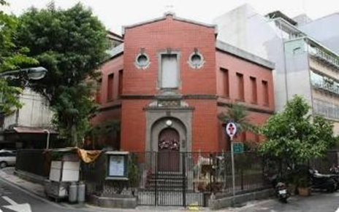
- Historical Insight: This church was built to commemorate Taiwan's "Father of Tea," Li Chun-sheng. As a Christian Comprador, he assisted John Dodd in marketing Formosa Oolong Tea to the United States. The church has a unique exterior that combines a Western church structure with a Southern Fujianese red brick style, making it an excellent testament to an East-meets-West cultural fusion.
- Route Guide:
Opposite or diagonally across from the church is the magnificent Former Residence of Chen Tian-lai.

Stop 5: Former Residence of Chen Tian-lai (Jin Ji Tea Co.)
Witness the luxurious life of wealthy tea merchants during the golden age of Dadaocheng.
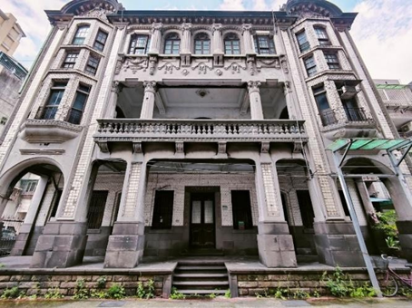
- Historical Insight:
Built in the 1920s, this exquisite Western-style mansion is the former residence of tea merchant Chen Tian-lai and the headquarters of the Jin Ji Tea Co. Its architecture presents a magnificent Baroque-style architecture, featuring delicate arcades, terraces, and gardens. Here, the tour guide can explain how wealthy merchants hosted European and American political and business figures during the peak of Dadaocheng's tea trade, leading high school and international students to imagine the prosperity of the "tea-scented years" a century ago.
- Route Guide:
Walk north along Guide Street to Minsheng West Road, cross the street, turn into Guisui Street, and look for the historical Salt Office.

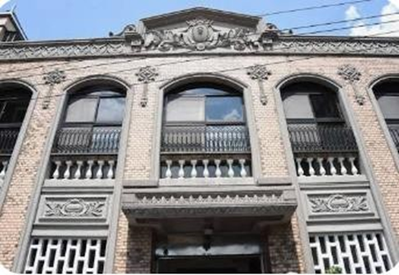
Stop 6: The Salt Office (Dadaocheng Koo Residence)
Turning into Guisui Street, explore the starting point of the rise of modern Taiwanese political and economic families.
- Historical Insight:
This historical building, blending Renaissance and Eclectic styles, was the residence of Koo Hsien-jung, a prominent Taiwanese figure during the Japanese colonial period. Because he acquired the "salt monopoly rights" at the time, it was called the Salt Office (or Koo Residence). This is a great starting point for the tour guide to explain the Monopoly System of the Japanese colonial period and the political and economic development history of modern Taiwanese families to the students.
- Route Guide:
Continue walking east along Guisui Street to arrive at Dadaocheng Park.

Stop 7: Dadaocheng Park (Li Lin-chiu Memorial Park)
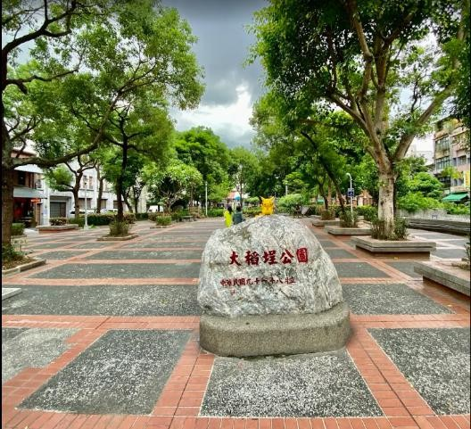
Take a short rest in the lush, green park while echoing music and history.
- Historical Insight:
Dadaocheng Park is also known as the Li Lin-chiu Memorial Park. The park features a statue of Li Lin-chiu and plays classic ballads like "Bang Chhun Hong" at scheduled times. Here, the tour guide can summarize the history from the first half of the tour and have the 20-person group take a Group Photo in the spacious park area as a souvenir.
- Route Guide:
Cut south from Dadaocheng Park back to Section 1, Dihua Street, and walk south back to Yongle Market.

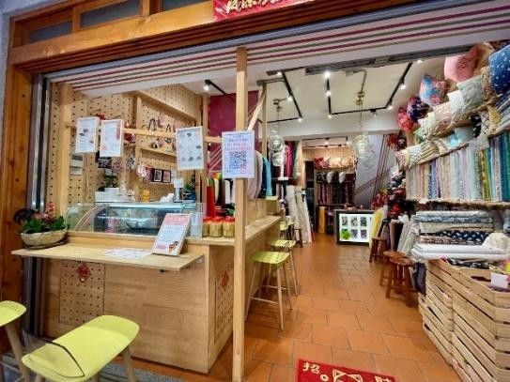
Final Stop: Dihua Street (Yongle Market)
Return to Taiwan's most famous distribution center for dry goods and fabrics to conclude the walking tour.
- Historical Insight:
Both sides of the Dihua Street historic district are lined with traditional dried goods shops and traditional Chinese medicine stores. Finally, you will arrive at Yongle Market, which is the hub for textile and fabric wholesale in Taiwan. The guide can explain how Dihua Street evolved from a transit hub for tea and dry goods during the Qing Dynasty into a revitalized district for contemporary cultural and creative industries, traditional Chinese medicine, and New Year goods for everyday people.

Follow-up Activities
After dispersing, participants can conveniently drink tea at nearby cultural and creative cafes on Dihua Street, or taste local Taiwanese snacks (such as herbal tea, rice noodles, and Spanish mackerel thick soup) around Yongle Market to foster deeper exchanges between Taiwanese and international students.

Tour Duration: Total of approximately 105-120 minutes
- Xia-Hai City God Temple (Starting Point): 20 minutes
- Guide Street Building Complex (Former Residence of Li Lin-chiu ➔ Chuang Hsieh-fa Shop ➔ Li Chun-sheng Memorial Christ Church ➔ Former Residence of Chen Tian-lai): 35 minutes
  - (The attractions in this area are highly concentrated; mostly exterior explanations are provided, and movement is swift)
- The Salt Office ➔ Dadaocheng Park (click to open the side panel to view more information): 20 minutes (includes using the restroom in the park and taking a group photo)
- Stroll along Dihua Old Street ➔ Yongle Market (Final Stop): 30 minutes

